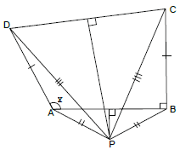Problem: Given the obtuse angle $x$, we make a quadrilateral $ABCD$ with $DAB = x$, and $ABC =90°$, and $AD=BC$. Say the perpendicular bisector to $DC$ meets the perpendicular bisector to $AB$ at $P$. Then $PA=PB$ and $PC=PD$, so the triangles $PAD$ and $PBC$ have equal sides and are congruent. Thus $PAD=PBC$. But $PAB$ is isosceles, hence $PAB=PBA$. Subtracting gives $x=PAD-PAB=PBC-PBA=90°$.

Where is the mistake in the “proof" and why does the argument break down there?

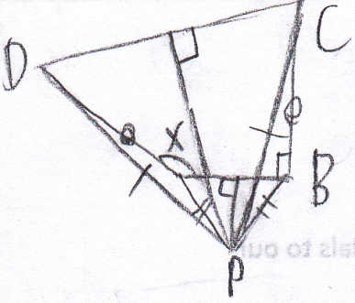

Solution: Try redrawing the diagram, using a ruler to measure exact lengths for reference when drawing lines of equal length. It turns out that segment PD actually lies on the opposite side of A from where it is on the given diagram above. The flaw in the reasoning is that it turns out that $x$ is not equal to $PAD-PAB$, but to $360°-PAD-PAB$; therefore, the measure of $x$ is indeterminate with the information given.